Verified site on various platform such as:

1. macOS (MacBook pro, V 15.4) – in different resolution
2. IOS mobile (iPhone 13, V 15.4.1)

Verified in different browser:

1. Safari
2. Chrome
3. Mobile Landscape and horizontal view

Found critical issues: 2

Found low severity issues: 1

Observations: 5

**Issues**

**Issue 1:** Textbox expands limitlessly

Severity of the issue: 3/4

Issue location: Customer service page => “Send us an email” page

Steps to reproduce:

1. Open Video slots main page
2. Click on “Customer service” link on header list
3. Customer service page will open
4. Navigate to “send us an email link” and click on it
5. “Contact our support” page will open
6. Verify “message” text box whether it stretchable or not

Actual Result: Textbox is adjustable, but it is stretch limitlessly

Expected Result: At some point, textbox should stop expanding. So, it cannot affect the site’s design

Suggestion: It is good to have character limit on textbox

**Evidence:**

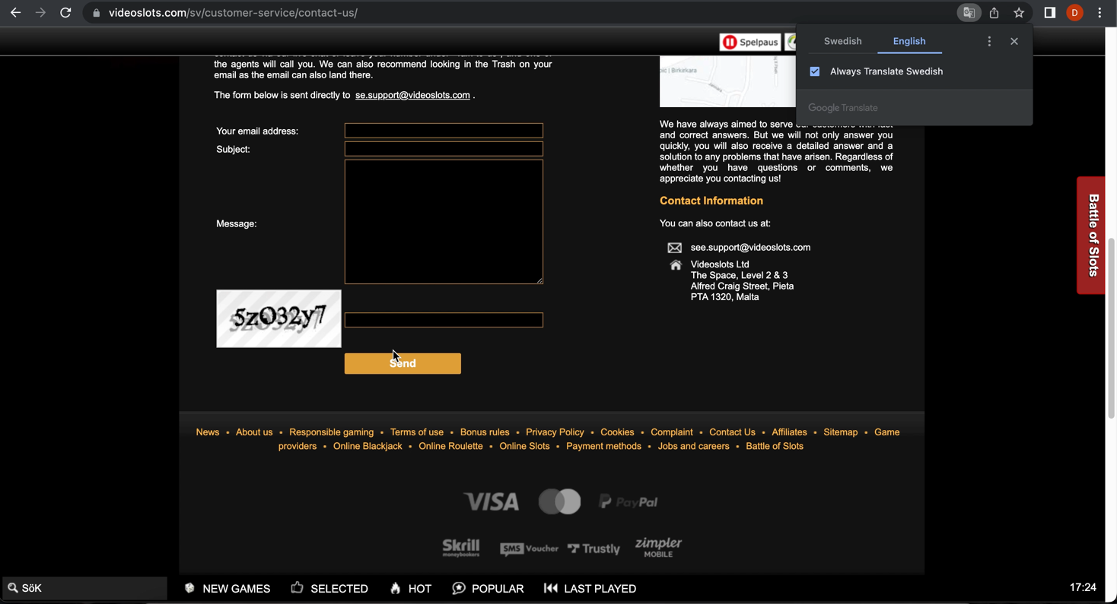

**Issue 2:** Odd format dropdown is not properly responding

Severity of the issue: 2/4

Issue location: Live sport

Steps to reproduce:

1. Open Video slots main page
2. Navigate to secondary nav and click on “Live sport” link
3. Select any game from the list
4. Verify “Odd format” dropdown below list of games in left rail
5. Open dropdown and verify dropdown item
6. Now select option and check whether it changes value according to selection

Actual Result: Dropdown item does not display properly. After selecting “fractions”, it still displays decimal item on dropdown and not apply any changes on page accordingly

Expected Result: On selecting different item, it should change the format of numbers and should display as selected on dropdown.

NOTE: It is working properly without translating language to English.

**Evidence:**

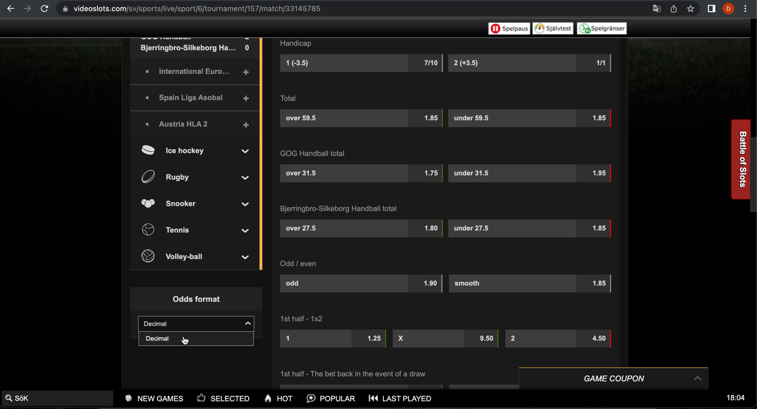

**Issue 3:** “Customer service” link is not working when “Live Support” page is opened.

Severity of issue: 2/4

Steps to reproduce:

1. Open Video slots main page
2. Then open “live sport” page
3. When it opened, click on “customer service” link placed on header
4. Verify if the page is opens or not

Actual Result: Customer service page is not opening when “Live Support” page is opened.

Expected Result: Customer service page should open.

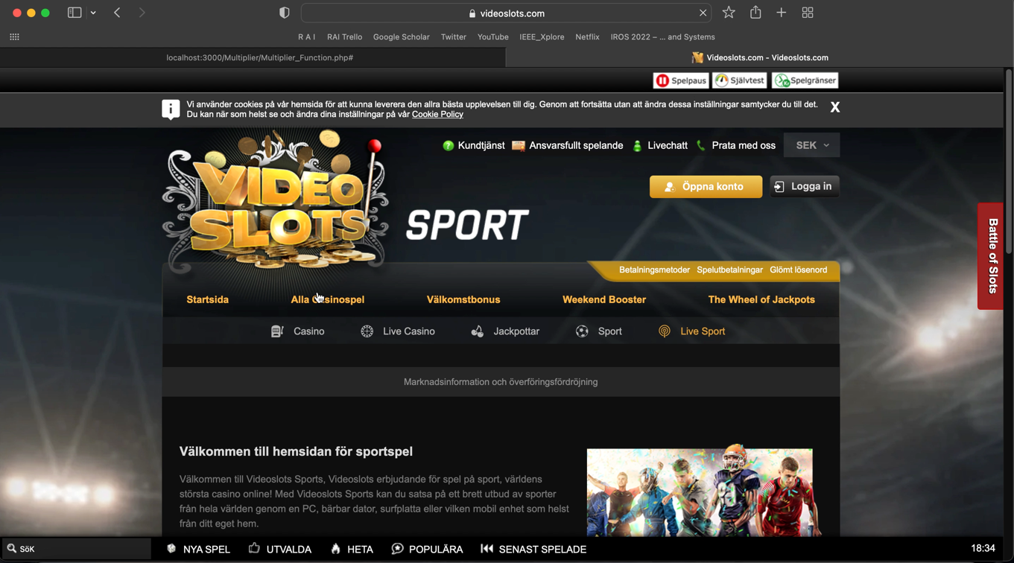**Evidence**:

**Minor Observations during testing:**

1. When the other applications are running, Video slot site takes time to perform an activity. Which might be frustrating for user. So kindly consider increasing performance
2. In home page, news container has content overlapping issue which is minor but good to be solved
3. Battle of slot pop-up: In table, when new user scrolls down, header hides. So, user must scroll up to see the header for better understanding the table value
4. Home page: In type of games dropdown, no. of rows that user want to set seen as item whereas site has already separated dropdown for that
5. In Mobile landscape view, fonts and design of site seems too big and user cannot read and see the site properly

Kindly ignore the observation if they are expected or OOS as I am unaware about the requirements and specification of the site.